During Cloudera installation you will get following page where we choose CDH version

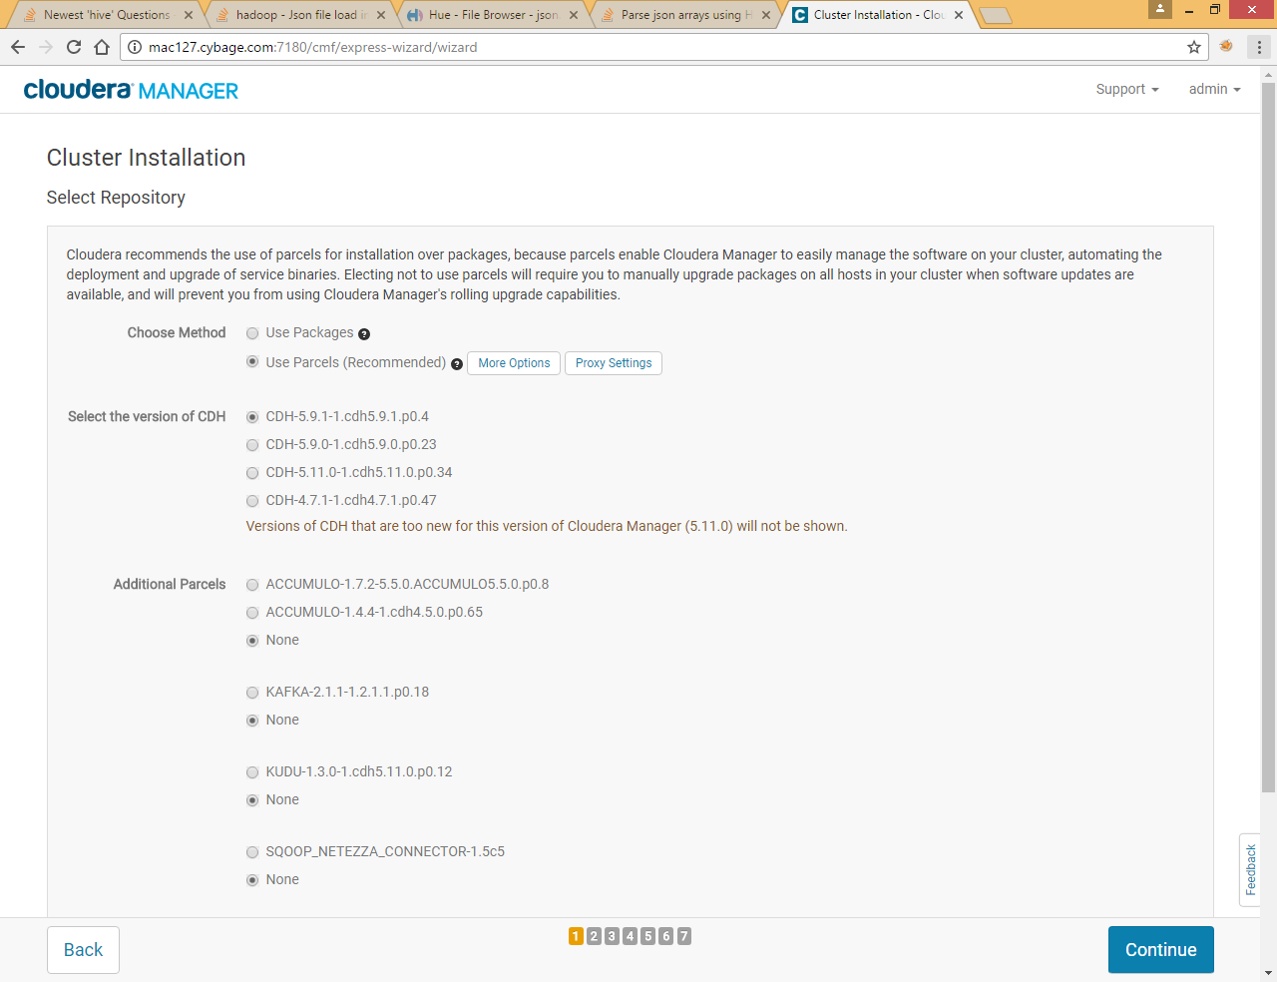

Currently only 4 versions are displayed when we selected parcel option, to add some other version just click on More Options

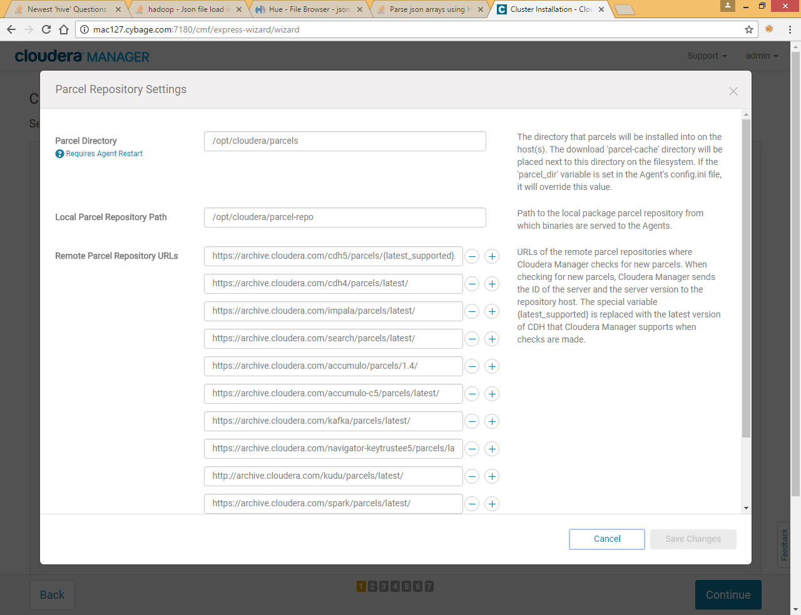

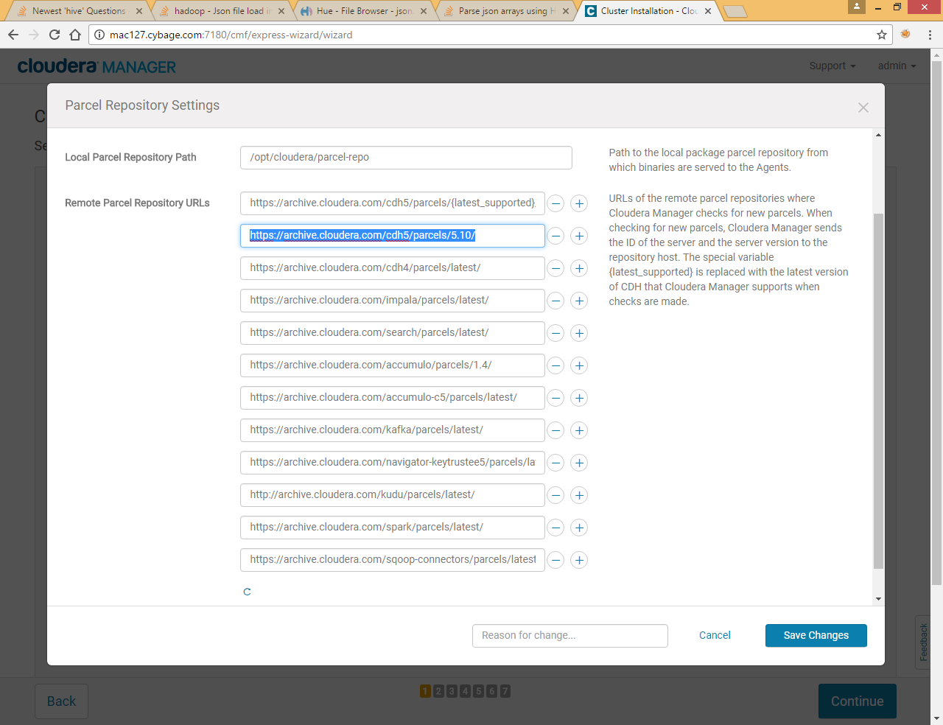

Now click on + sign to Add new parcel and enter URL of specific CDH version

Click on save change

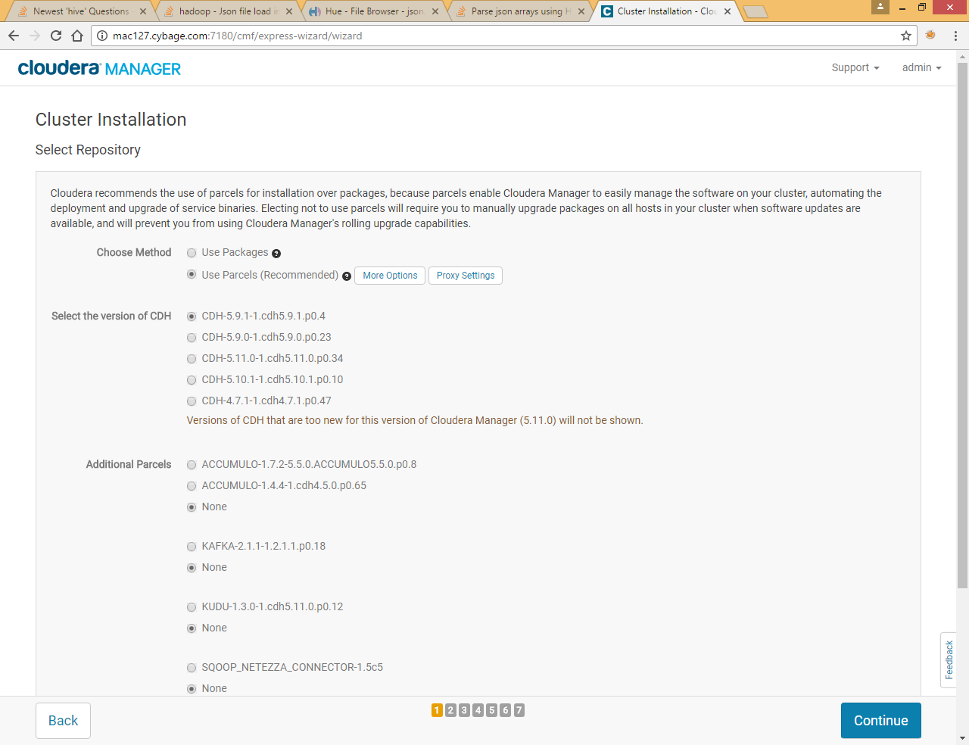

You will get CDH 5.10 version now, you can select it and click on Continue